**IOT - Google Assistant with Python On Raspberry Pi**

**Basic Prerequisite:**

**Google Assistant:-**

**Google Assistant** is an [artificial intelligence](https://en.wikipedia.org/wiki/Artificial_intelligence) powered [virtual assistant](https://en.wikipedia.org/wiki/Virtual_assistant) developed by [Google](https://en.wikipedia.org/wiki/Google) that is primarily available on [mobile](https://en.wikipedia.org/wiki/Mobile_device) and [smart home](https://en.wikipedia.org/wiki/Home_automation) devices. Unlike the company's previous virtual assistant, [Google Now](https://en.wikipedia.org/wiki/Google_Now), the Google Assistant can engage in two-way conversations.

Users primarily interact with the Google Assistant through [natural voice](https://en.wikipedia.org/wiki/Natural_language_processing), though keyboard input is also supported. In the same nature and manner as Google Now, the Assistant is able to search the Internet, schedule events and alarms, adjust hardware settings on the user's device, and show information from the user's Google account.

**IFTTT:-**

**If This Then That**, also known as **IFTTT** is a freeware [web-based service](https://en.wikipedia.org/wiki/Web_service) that creates chains of simple [conditional statements](https://en.wikipedia.org/wiki/Conditional_(computer_programming)), called [**applets**](https://en.wikipedia.org/wiki/Applets).

An **applet** is triggered by changes that occur within other web services such as [Gmail](https://en.wikipedia.org/wiki/Gmail), [Facebook](https://en.wikipedia.org/wiki/Facebook" \o "Facebook), [Telegram](https://en.wikipedia.org/wiki/Telegram_(messaging_service)), [Instagram](https://en.wikipedia.org/wiki/Instagram" \o "Instagram), or [Pinterest](https://en.wikipedia.org/wiki/Pinterest" \o "Pinterest).

**Usage examples**

* **IFTTT** can automate web-application tasks, such as posting the same content on several social networks.
* **IFTTT** also is used in home automation, for instance switching on a light when detecting motion in a room (with associated compliant devices).

**Hardware:**

* Raspberry Pi
* Jumper Cable
* Resistors
* LEDs

**Account Setup:**

* Download and Install Google Assistant from google playstore and signup with your email or create an account.
* Open browser and goto “IFTTT.COM” and create an account with your same email.
* If it will ask for verification, then provide your verification type such as backup-email, mob-no and finish verification successfully.
* Click ‘Create’ option, then click ‘**+**’, like below diagram.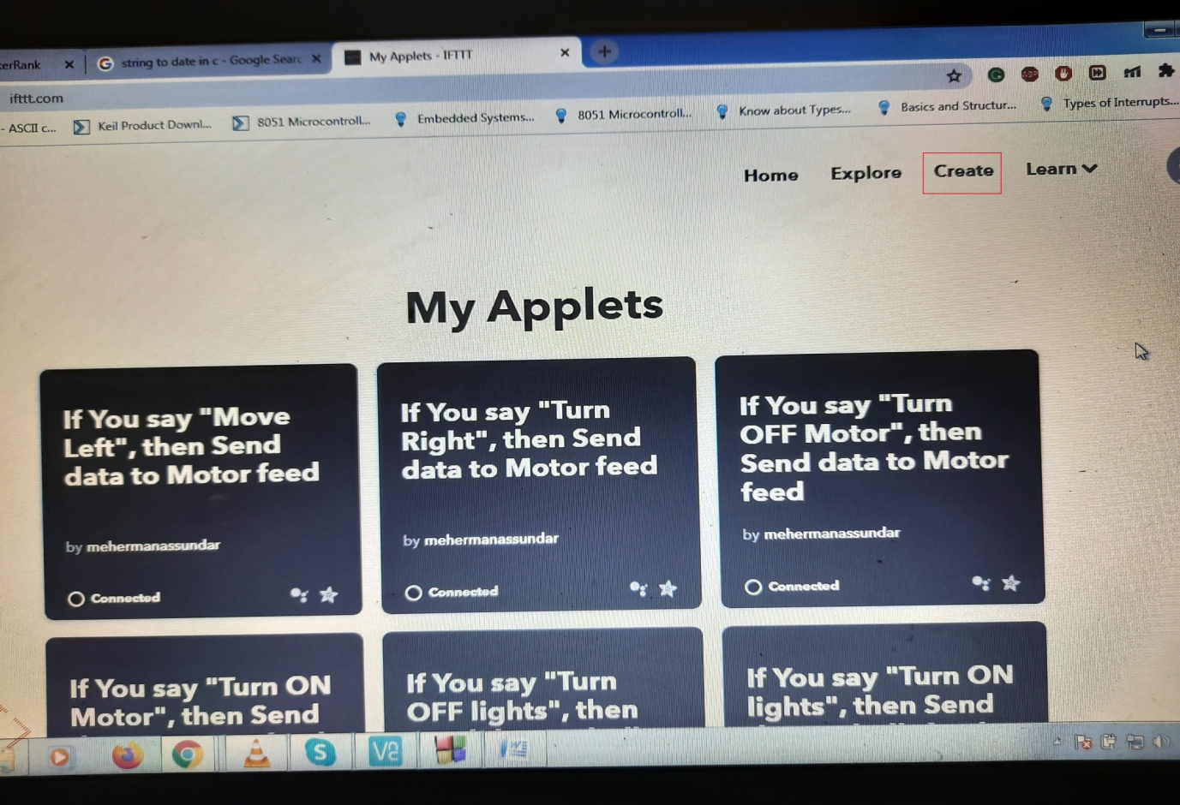

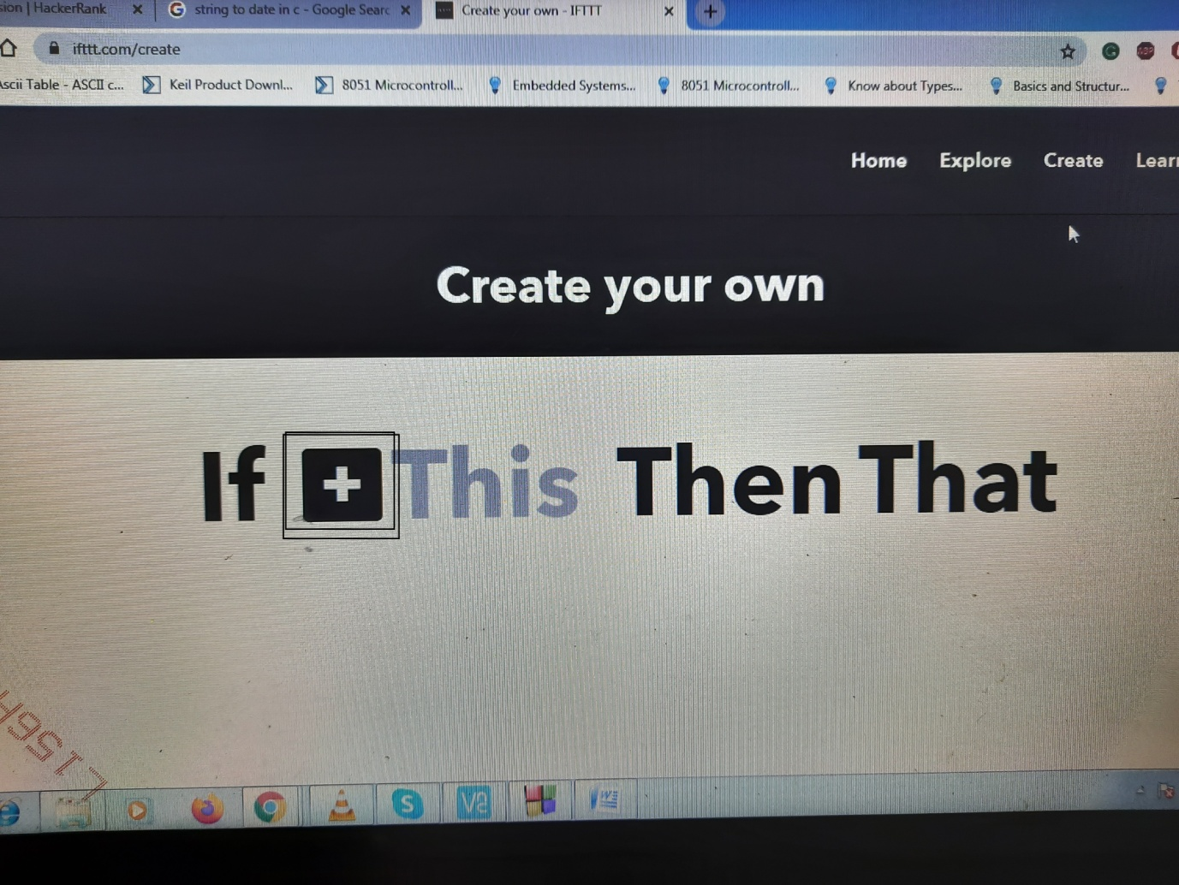

* Then in the page of “Choose a Service” search for “Google Assistent” select this like below diagram

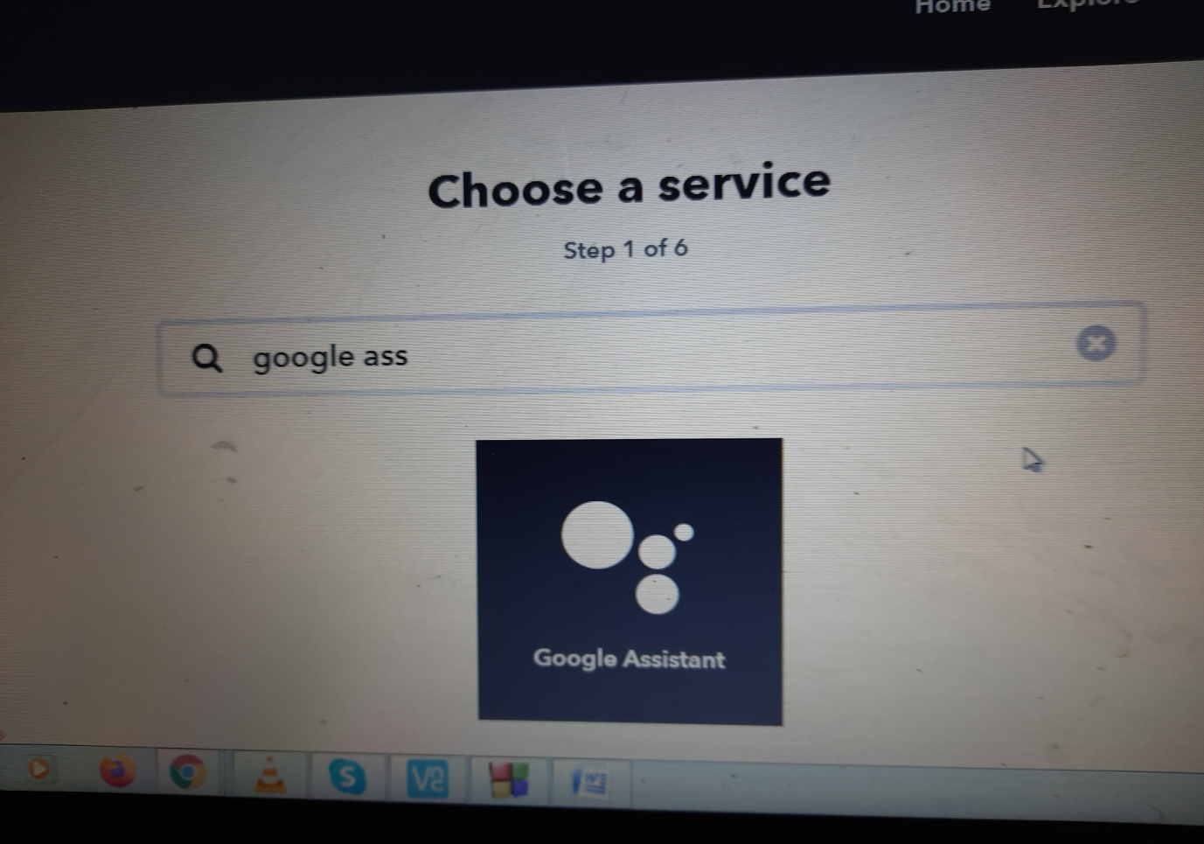

* This will open below page, then select as your appropriate option. For this project, I want to make simple one that’s why I choose “ Say a simple phrase”.

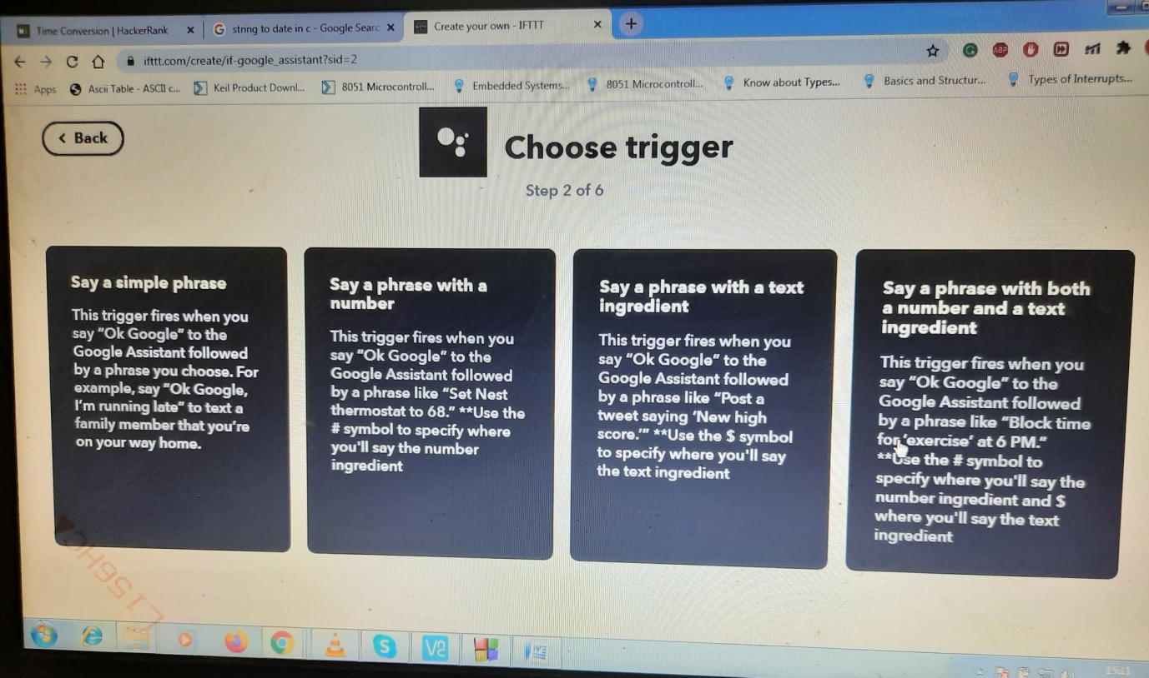

* It will open below page

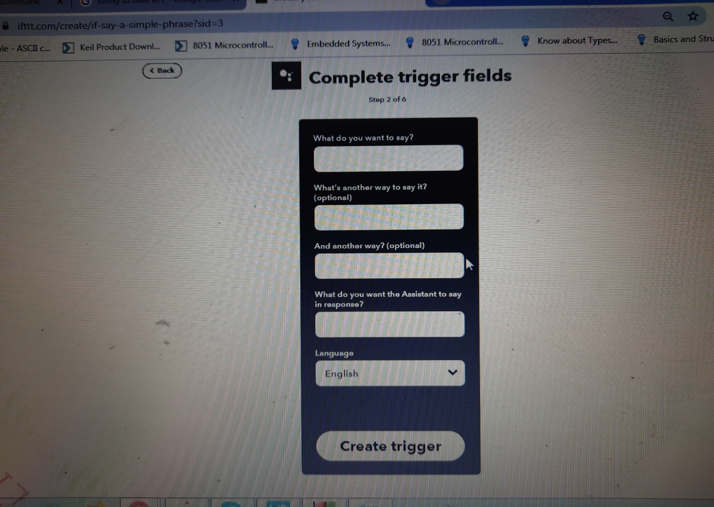

* Provide data like below diagram and click “Create trigger”.

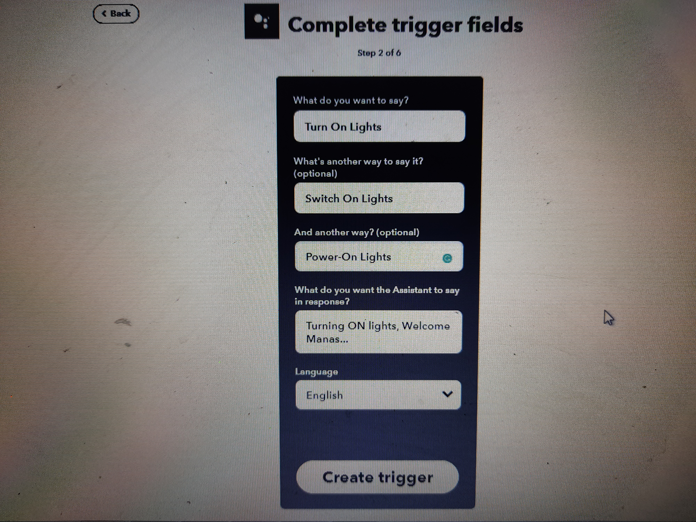

* Then click symbol “**+**” of That option, It will open “Choose Action Service” page, there you have to search “Adafruit” and click.

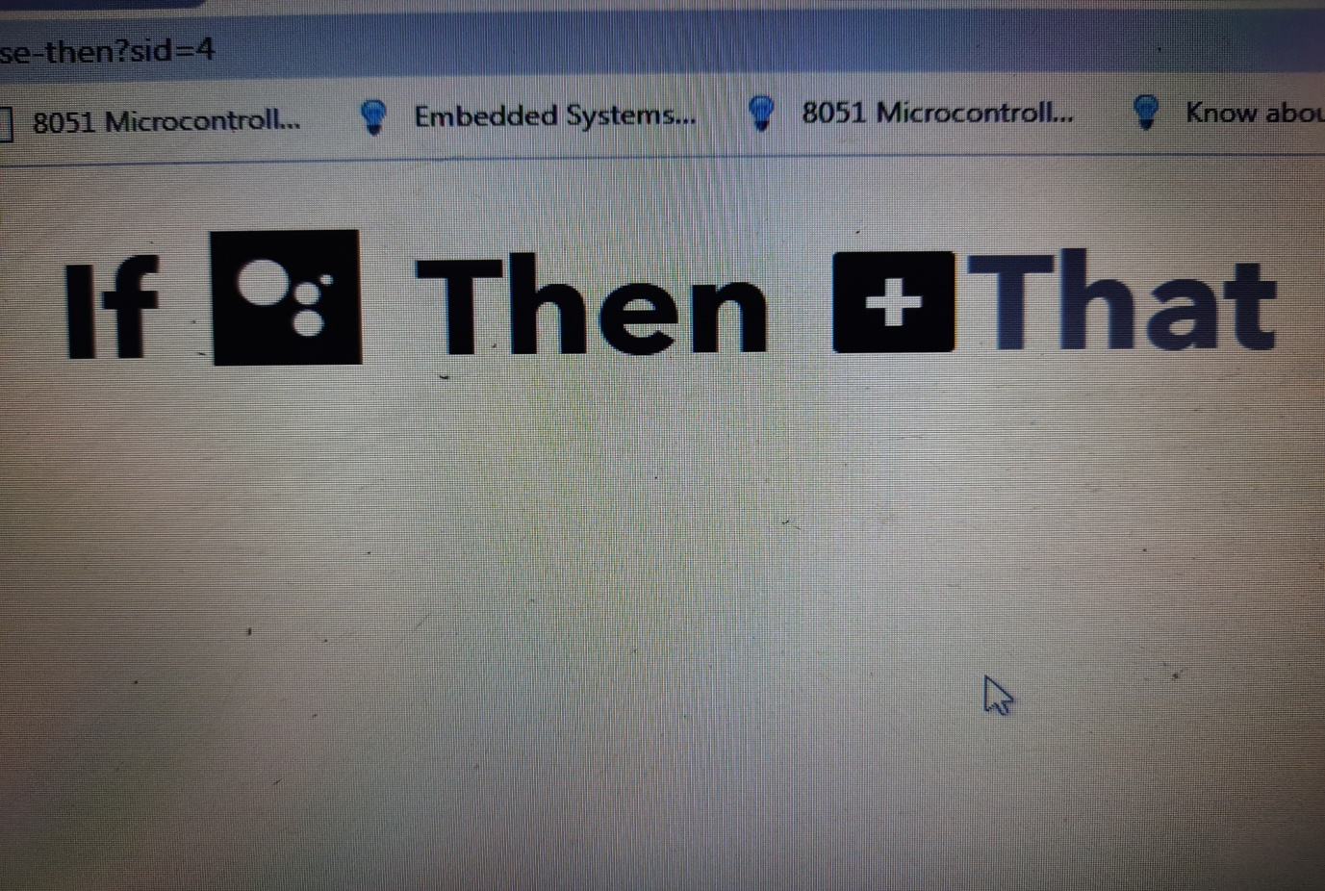

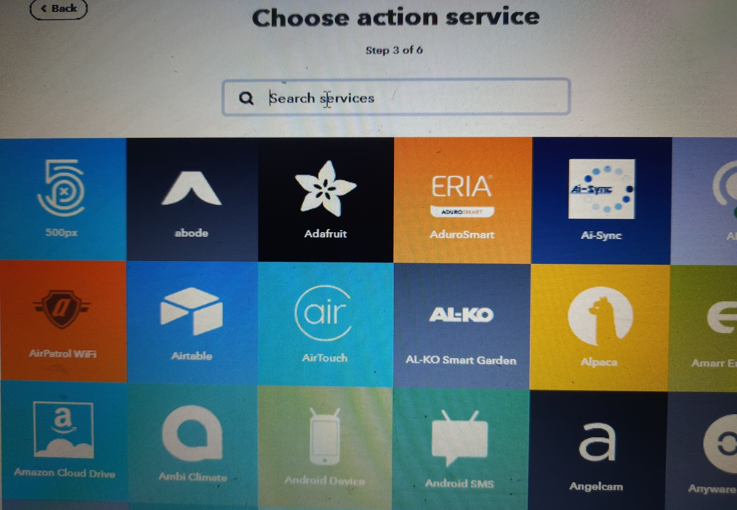

* It will open below page, then you have to click “Send data to Adafruit IO” and you will reach to “Complete Action fields”.

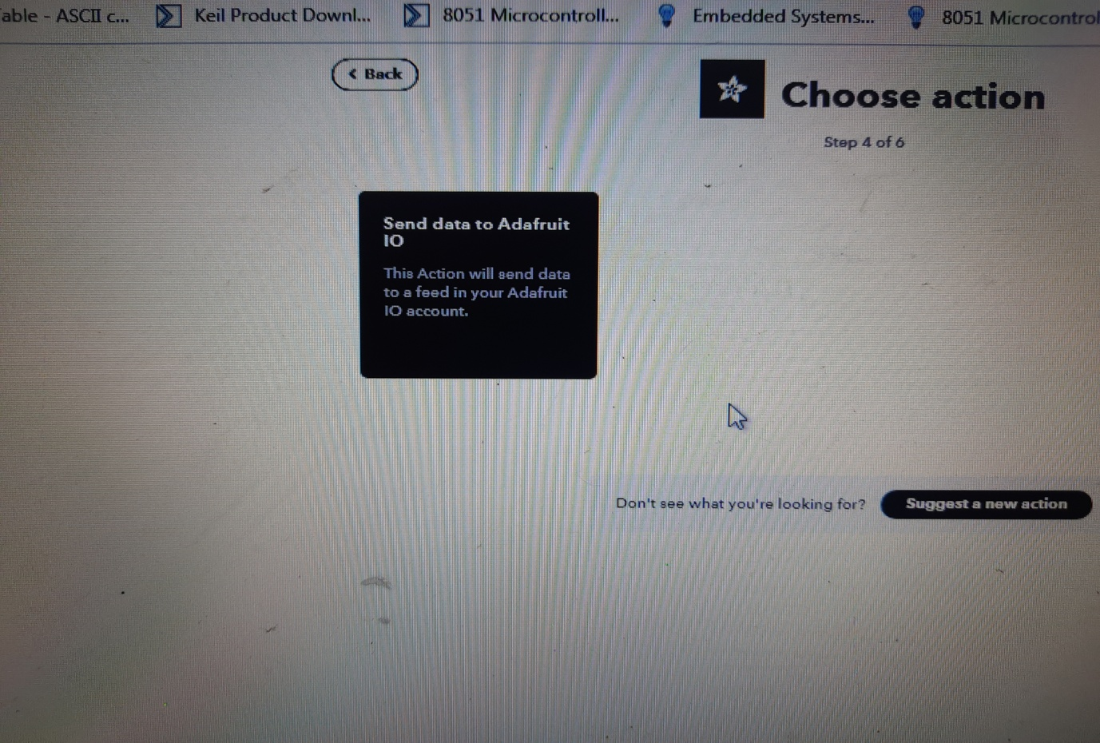

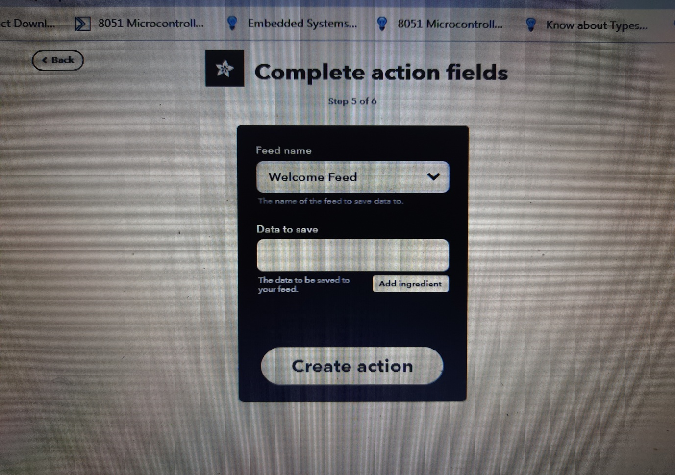

* Before proceeding further we have to do some settings like, Open another tab and google it for “adafruit io” and open “Welcome to Adafruit IO” page.
* Sign In or Sign Up with your previously used email.
* When you will login successfully, you will see a dashboard like below diagram

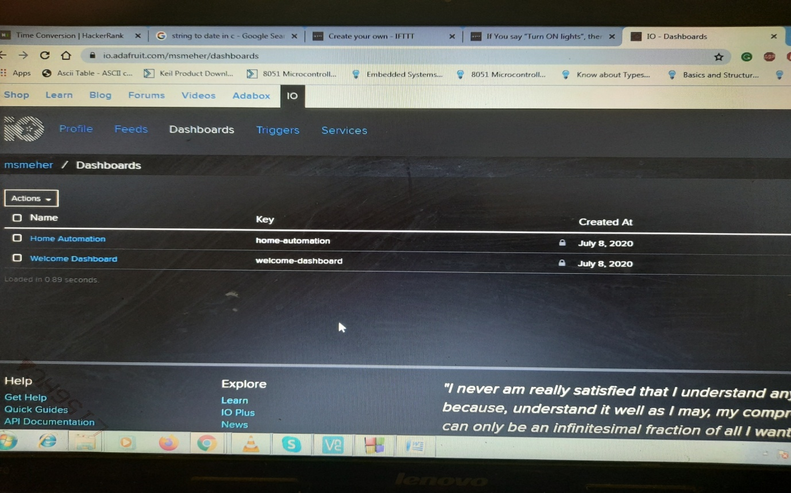

* Then create a dashboard by clicking “Action->Create a New Dashboard” and give it a name like “Home Automation”. You can see in my previous picture.
* Then go to Home Automation and click “**+**” and select a Toggle block(On or Off Switch) like below diagram.

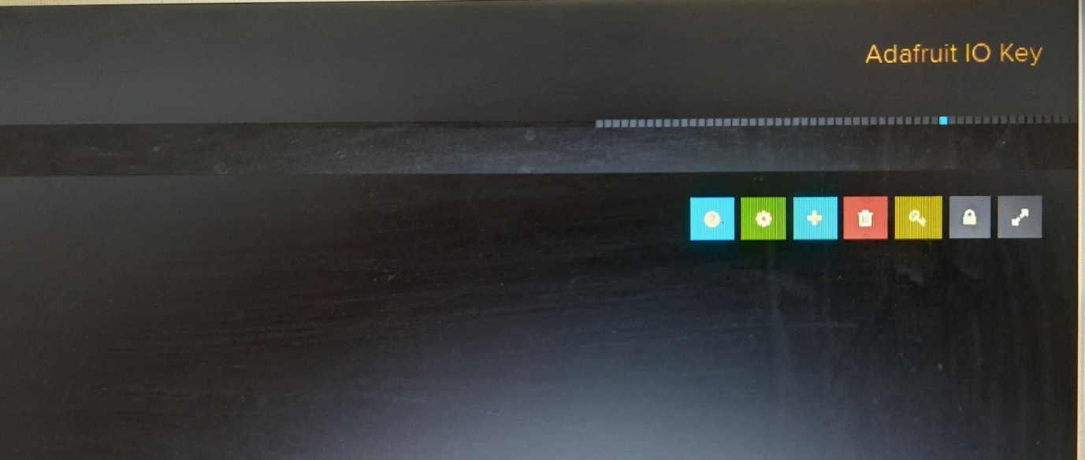

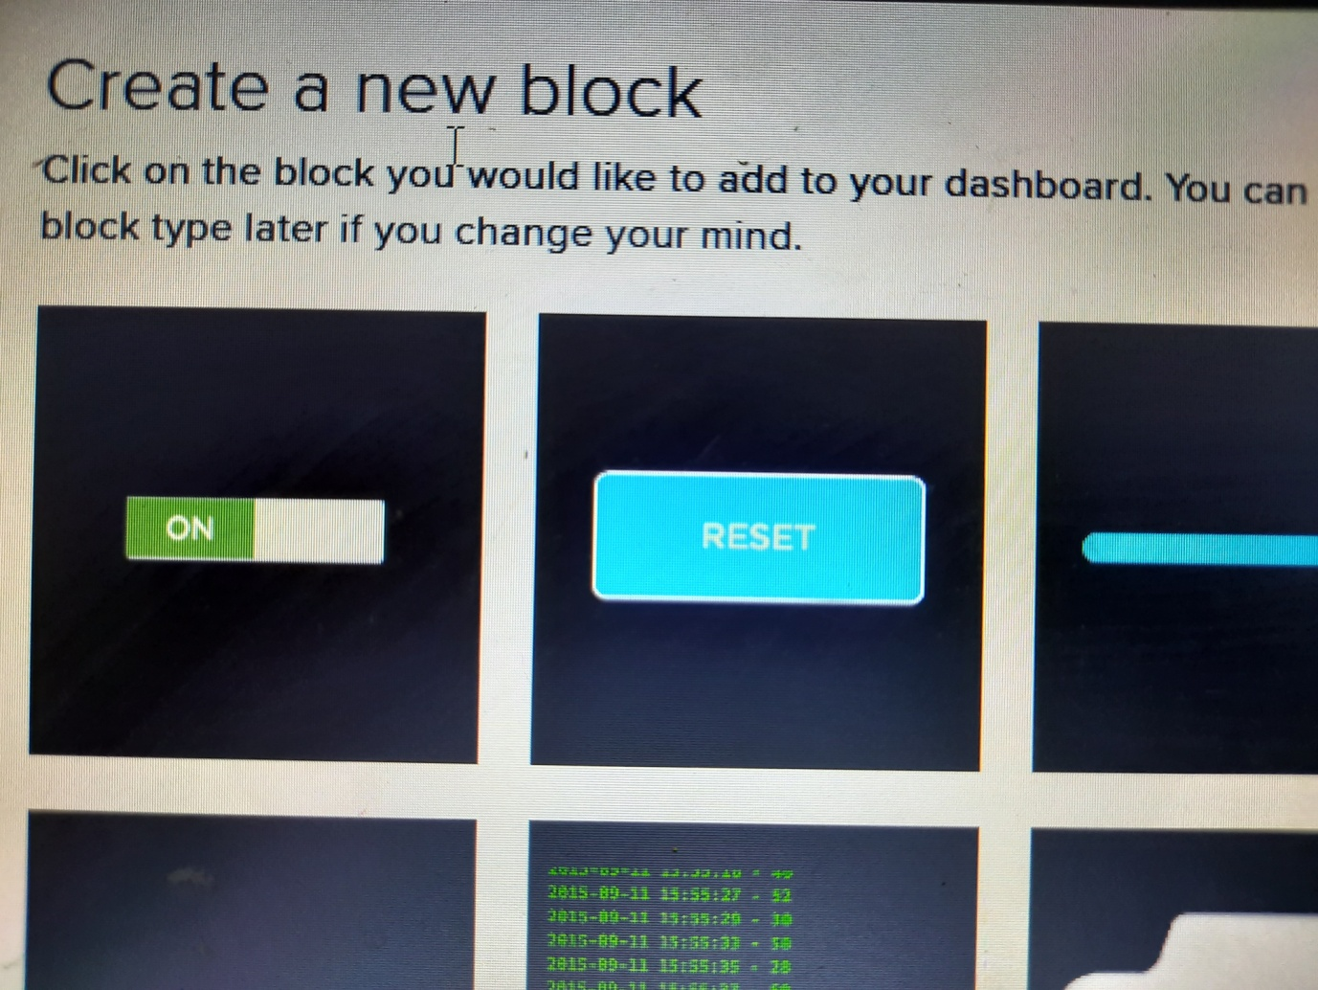

* After clicking Toggle block, it will prompt a page like below diagram, then create a feed name “bulb”, as I already created one.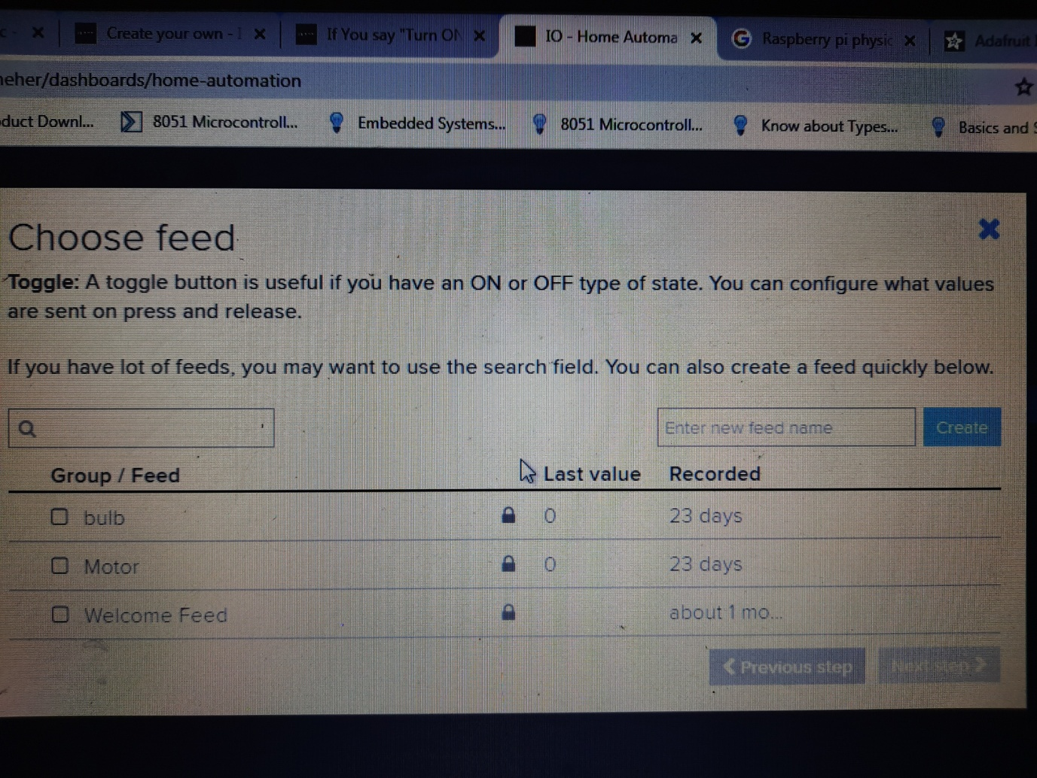
* Then select bulb feed and go to next step.
* In next page you can provide a block title i.e. optional. I have given “bulb ON / OFF” and click create block.

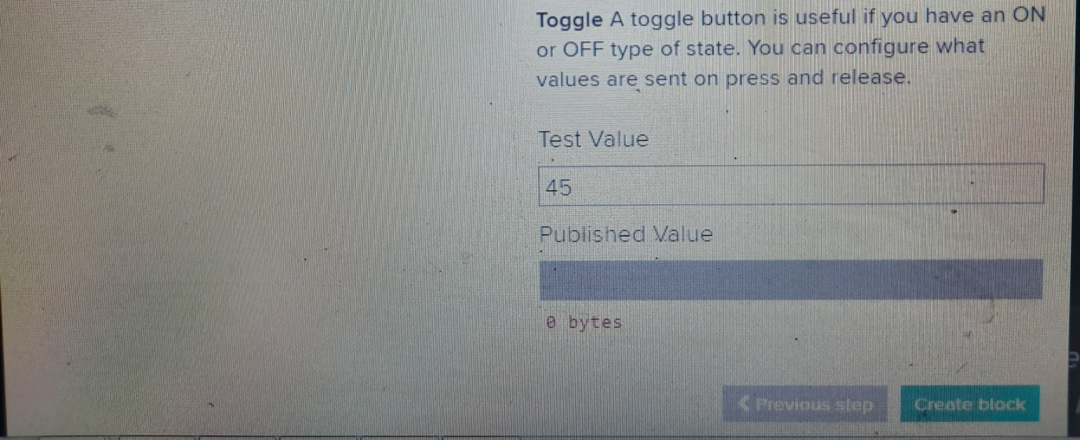

* Go back to “Complete Action fields” of IFTTT tab and select feed “bulb” and in the “Data to save” field you enter value 1.
* When you click “Create Action”, you will get below page, just verify and click Finish.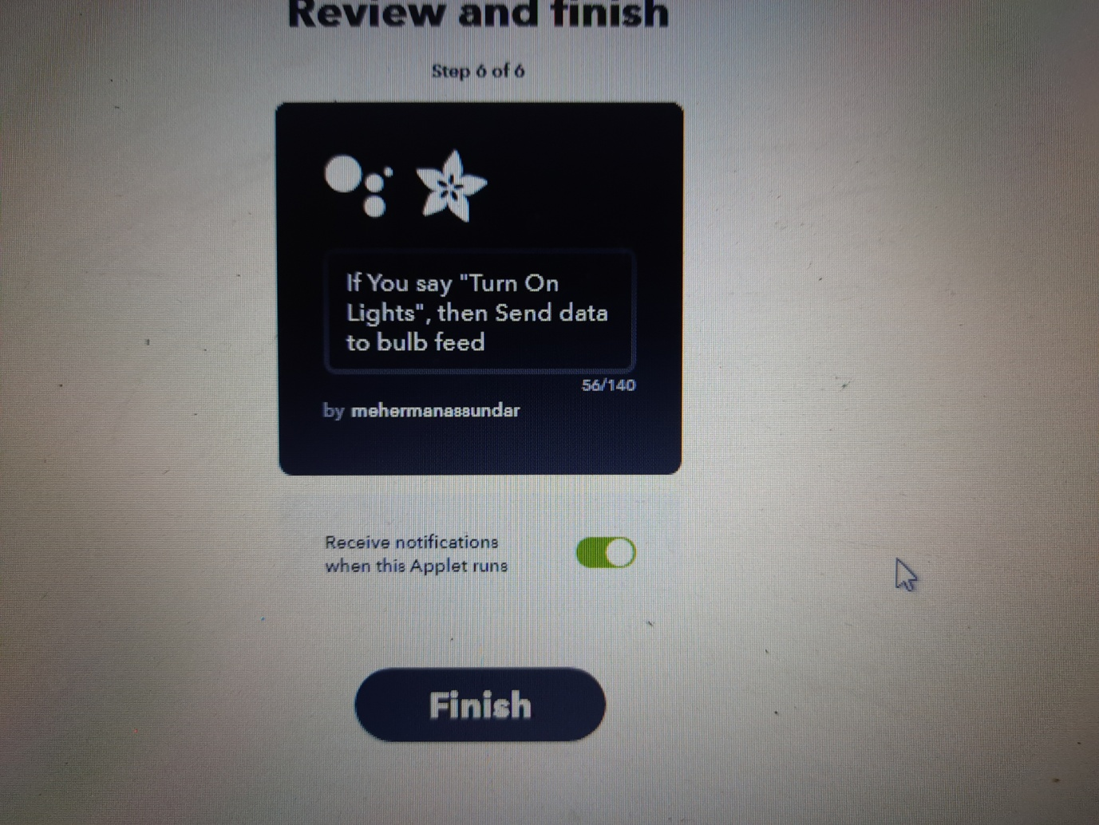
* Then open another tab and google search for “ Raspberry pi physical dashboard Adafruit io” or you can open this link “<https://learn.adafruit.com/raspberry-pi-physical-dashboard/adafruit-io?view=all>”, and use code.

OR

* Open your Pi-Terminal and create a python file name “HomeAutomation.py” and copy paste below code

**from Adafruit_IO import MQTTClient**

**import RPi.GPIO as GPIO**

**from time import sleep**

**import requests**

**ADAFRUIT_IO_KEY = 'XXXXXXXXXXXXXXXXXXXXXX'**

**ADAFRUIT_IO_USERNAME = 'XXXXXXXX'**

**GPIO.setwarnings(False)**

**GPIO.setmode(GPIO.BOARD)**

**GPIO.setup(8, GPIO.OUT, initial=GPIO.LOW)**

**def connected(client):**

**print('Connected, Listening changes...')**

**client.subscribe('bulb')**

**def disconnected(client):**

**print('Disconnected...')**

**sys.exit(1)**

**def message(client, feed_id, status):**

**if feed_id == 'bulb':**

**if status == '1':**

**GPIO.output(8, GPIO.HIGH)**

**print('Bulb ON, Welcome Again...')**

**else:**

**GPIO.output(8, GPIO.LOW)**

**print('Bulb OFF, Thank You...')**

**client = MQTTClient(ADAFRUIT_IO_USERNAME, ADAFRUIT_IO_KEY)**

**client.on_connect = connected**

**client.on_disconnect = disconnected**

**client.on_message = message**

**client.connect()**

**client.loop_blocking()**

* Some changes you need to do like in place of “ADAFRUIT_IO_KEY” and “ADAFRUIT_IO_USERNAME”, you have to put your details.
* For finding key and username you have to go to Adafruit->Dashboard->HomeAutomation then click the key symbol present right side of screen.
* If you click that you will be prompt like below diagram, then find username and key and copy paste in your program.

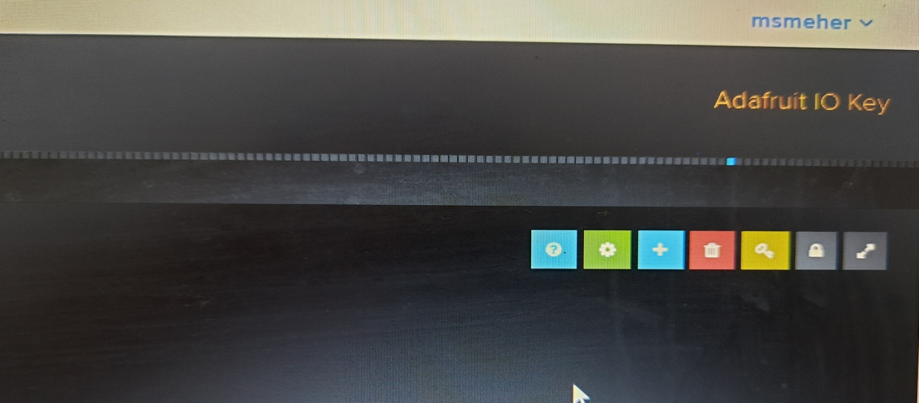

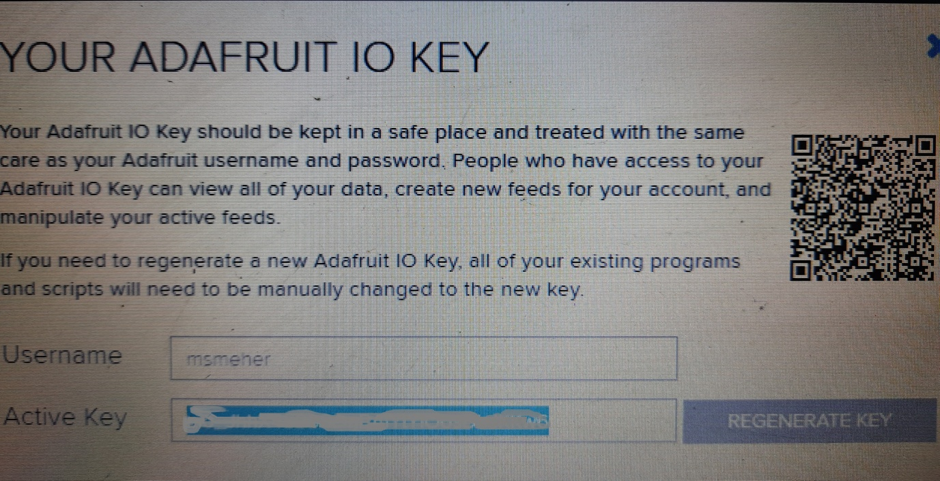

* Now again get back to IFTTT-Applet page click finish, It will show new connection created.
* Then again create another applet for “Turn OFF Lights”, follow the same procedure.
* Click Create then click “**+**”->search for “Google Assistant”->”Say a simple phrase” then set data like “Turn OFF Lights”, “Power OFF Lights” and “Switch Off Lights”.
* These keywords are important when you will use Google Assistant.
* After setting all value click “Create Trigger”.
* Then click “**+**” symbol select adafruit action service->send data to adafruit and set feed as “bulb” we created in adafruit site and set data value to 0 and finish creating applet.
* Now we finished all important part we just have to set Google Assistant App.
* Open app and login with your email which is used in this project.
* Now do your hardware connection as per your program and execute your python file (HomeAutomation.py) by using below command

**python HomeAutomation.py**

* Open Google Assistant say “Ok Google” to start communication then say different phrase which we set such as “Turn On Lights”, “Turn Off Lights”, “Power On Lights”, “Power Off Lights”, “Switch On Lights” and “Switch Off Lights”
* Now Finally check your connected LED, It toggle.
* You can connect any type of electrical device in place of LED, but before that you get full knowledge on Electrical Connection on High Voltages because it is little bit more risky.